Name | Julia Abdel-Monem | Team | Tappa Tappa Keyboard | TL | 6 | Date | 2024-11-11 | Time | 08:30
Fill in the underlined areas (and the boxes above), now but don’t write on the remainder of this form.
Contribution: Briefly describe what your feature(s) is/are:  User Interface/User Experience. All Menus and HUD elements, as well as the game manual, Readme, and Changelogs  Walk me through your Gantt chart. How long did this take? How long did you estimate it would take? What did you learn about your skill as an estimator?  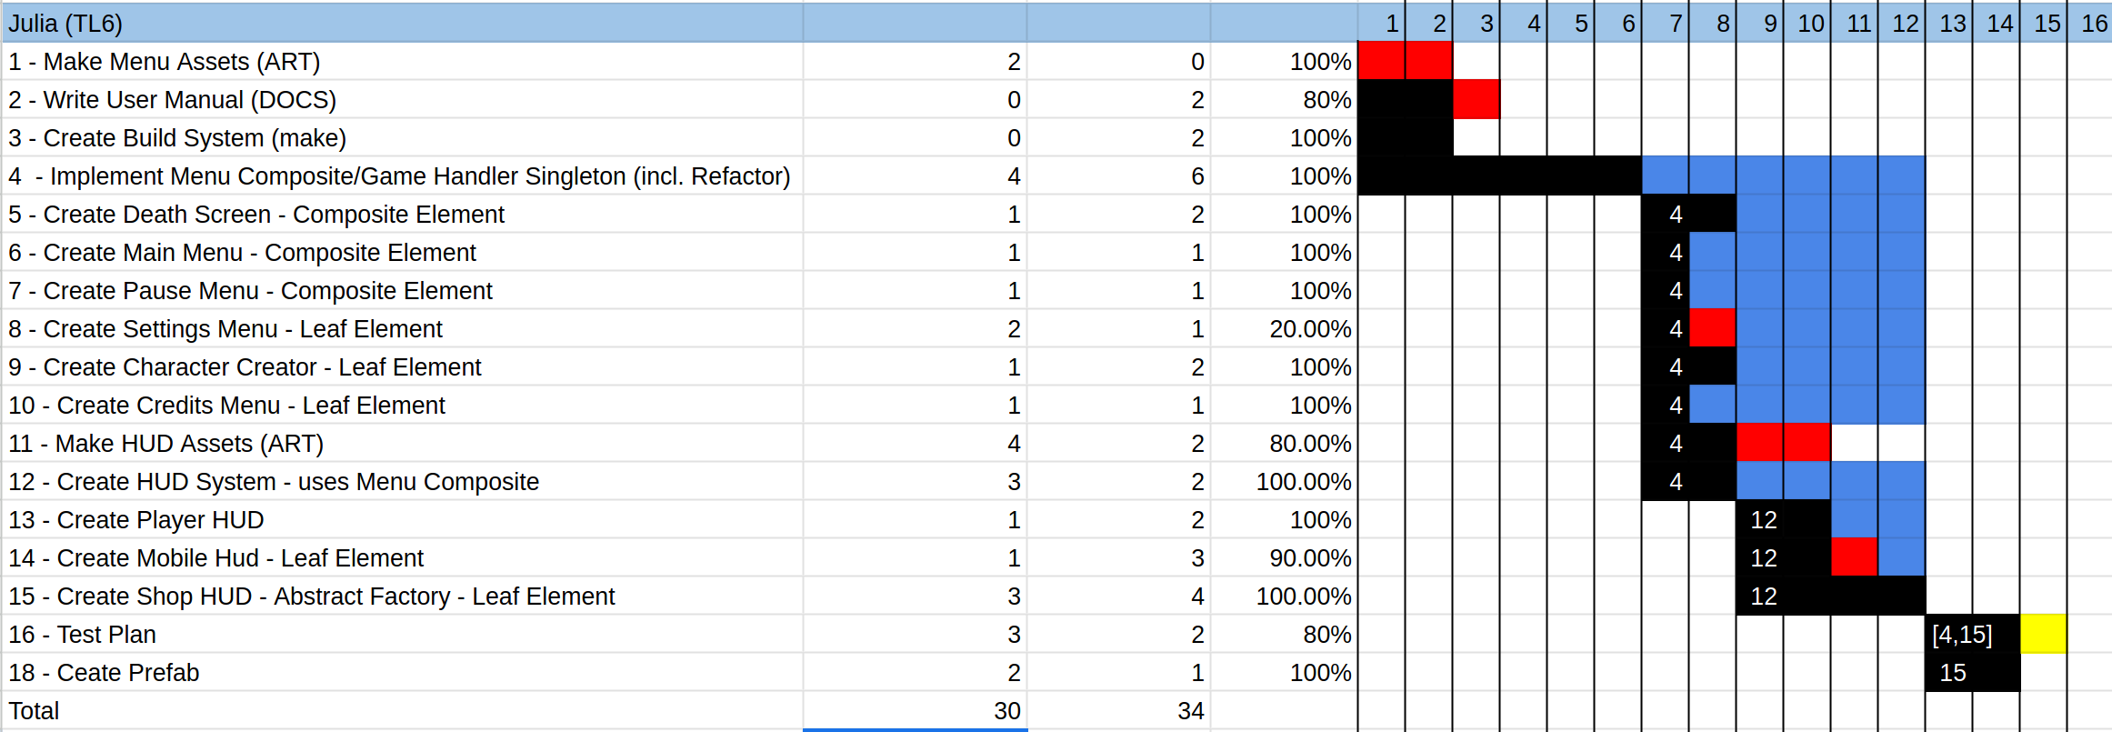  I've spent about 34 hours working on the game, and I estimated that it would take me 30 hours. I learned that I underestimate the time it takes to write code/implement specific elements, since I did not account for time taken to research possible solutions. I also did not factor learning c# into the amount of time it would take, since I had expected certain elements to be easier/more similar to what i've worked with in the past.  Run your game and point out places where your code is called and run. (I will cycle through asking you this question and the next one until you either run out of interesting things to talk about or it is clear that you have made an above average contribution.)  Show the C++/C# code that was run. Walk me through the methods called from the time it enters your section of code. | /10
Technical:  Walk me through your test plan. Give an example where a test case later found a bug in your code by things a teammate added later. (Or explain why you chose a test case specifically because you wanted to ensure that a teammate would know if they broke your code.)  Testing the bounds of the heart grid was useful in ensuring that the HUD element was still in a valid state even after the player character makes specific requests, such as making sure that my code did not try to access invalid elements of the array or try to display a value out of bounds.  Heart Grid  test_init()  - ensure that the unit works  test_increase_health()  - ensure that when health is increased to a point above MaxHealth that it does not create any elements or crash from trying to access non-existent nodes  test_increase_max_health()  - ensure that the expected number of hearts is generated  test_full_init()  - ensure that the module is behaving as expected  test_num_max_hearts()  - stress test on the number of hearts possible in a scene. Takes a while before anything crashes  Shop  test_factory_generation()  - ensure that the correct number of elements is generated  test_basic_buying()  - ensure that money is being subtracted when a user buys an element  test_price_increase()  - ensure that the price is incremented when a user buys an element  test_storage()  - ensure that when a shop closes and reopens, that the price is still the same.  test_too_little_money()  - ensure that the shop does not purchase anything if money is too low  test_buying_until_too_low()  - similar boundary test, but it approaches the boundary.  test_num_max_purchases()  - stress test where the buy button is pressed over and over again  Menu Composite  test_basic_functionality()  - ensure that the menu composite works as expected, (pushing, popping, etc...)  test_pop_empty()  - ensure that when the container is empty and pop() is called that it behaves in an expected way  test_pop_unpoppable()  - ensure that Poppable() == false works  test_remove()  - ensure that the right node is selected and is removed.  test_clear()  - ensure that all nodes are removed without calling on_pop()  test_index()  - ensure that lower and bounds are respected  test_push_limit()  - stress test the maximum number of leaves on a single composite  test_on_push()  - ensure that OnPush() is called as expected  test_on_pop()  - ensure that OnPop() is called as expected  test_on_show()  - ensure that OnShop() is called as expected  test_on_hide()  - ensure that OnHide() is called as expected  test_same_name()  - ensure that if two nodes are pushed with the same name that the module responds in a well-defined way  test_double_remove()  - ensure that if an element is called to be removed twice that behavior is expected  test_child()  - test Child() getter to ensure that it works as expected  Game Handler  test_start_game()  - ensure that GameHandler opens the correct scene and a character is chosen.  test_stop_game()  - ensure that elements are cleared on game exit  test_load_main_menu()  - ensure that loading the main menu works as expected.  ________________________________________________________________  Pick a Prefab you have created that is documented well in a separate readme file.  (I will point to several places in your code documentation and ask) What question where you trying to answer here? Who do you anticipate would be asking that question? What other questions might this person need the answers to?s  Prefab Name: GodotMenuPrefab (in the original GIT repo as BaseClasses)  (link to code and documentation) - https://github.com/MusicalArtist12/GodotMenuPrefab  Show me a class in your code where there could be either static or dynamic binding. Write some mock code on this paper showing how you would set the static type and dynamic type of a variable.  Super Class: ShopElement  Sub Class(es): MaxHealthIncrease, FullHeal, DamageIncrease, SpeedIncrease,  ShopElement[] elements = new ShopElement[4]  elements[0] = new MaxHealthIncrease();  elements[1] = new FullHeal();  elements[2] = new DamageIncrease();  elements[3] = new SpeedIncrease();  Virtual Function: public virtual int Buy(int Money)  Choose a dynamically bound method. What method gets called now?  elements[0].Buy(PlayerGlobal.Money) -> MaxHealthIncrease.Buy()  Change the dynamic type. What method gets called now?  elements[0].Buy(PlayerGlobal.Money) -> ShopElement.Buy()  Pick a statically bound method. Which one would be called in each of the two previous cases?  public int ButtonPressed()  {  PlayerGlobal.Money = Buy(PlayerGlobal.Money);  }  elements[0].ButtonPressed() -> ShopElement.ButtonPressed()  Show me an example of reuse in your code where you violate copyright law.  Mario Coin Asset  How does it violate copyright? Using an asset without modification and for the original purpose  What did you have to do to integrate it with the code you wrote? What are the legal implications if you market your code with the re-used portion? Use fair use argue that you can use this anyway.  Legal Implications: I could be suied by Nintendo for use of a copyrighted  work in a game that I made. I would argue that the usage of the asset is parody, claiming that the usage of the commenting on Nintendo's assumption of a capitalist society in Super Mario.  4. One big or two small, well-chosen patterns.  Small Patterns = {Singleton, Private Class Data}  Which patterns did you choose?  1. Composite on the Menu System  Why did you choose each pattern? (Justify your use of it).  The Menu system needed to be a tree of elements during runtime, since i'd need to be able to easily manipulate it while also keeping it coherently toghether, and its easily representable as a tree of composite structures and leafs that are presented in the structure.  Draw the class diagram for your pattern(s).  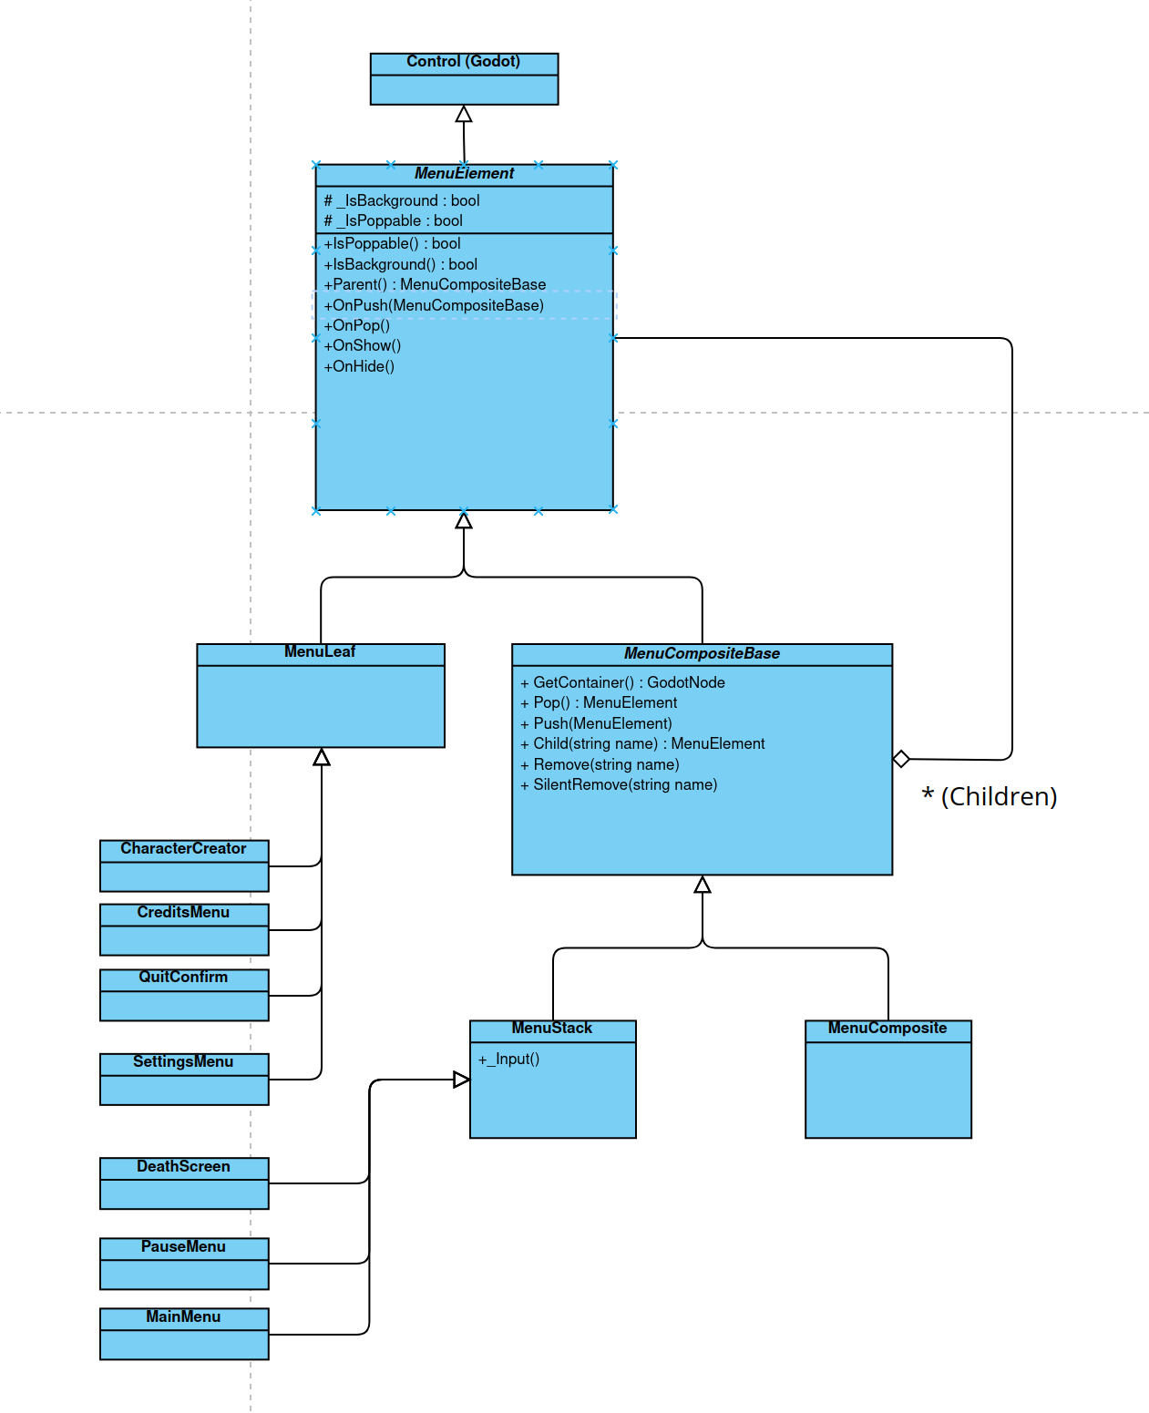  Would something else have worked as well or better than this pattern? When would be a bad time to use this pattern?  A composite worked really well here, since I piggybacked off of Godot's composite structure for mine. That being said, I originally went with a Singleton + State Machine for the menus since I only ever needed one main menu and could call each elements of the main menu a state.  I would not use this pattern to design anything where the relationships between nodes are only one-to-one, since it would not take advantage of composite's many-to-one relationship structure. | /4  /3  /3  /4  /4

